28. Design DFA using simulator to accept the string the end with ab over set {a,b)

W= abbaabab

*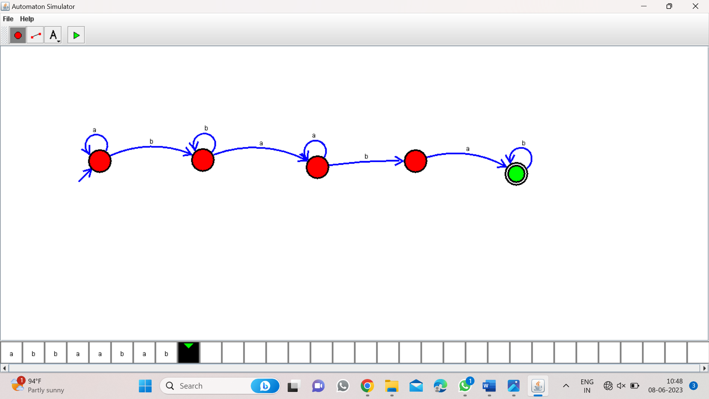*

Result:

Hence, accepted the input string the end with ab over set{a,b} by using DFA simulator